Name: | ___________________________________________ |  |  |  | Date:__________
 | Maths Specialist Unit 2, Investigation 3 – 2015  Trigonometric Graphs and Functions Take home component
Important Information:
Although the take-home component is not worth any marks, it is essential in preparation for the in-class component. Knowledge and skills gained will be extended in the in-class validation component. This in-class validation will be completed under test conditions on the day in which this take-home component is due. The take-home component may be used when completing the in-class component. Contact may be made to parent(s) if the take-home component is not available for submission (at the start of the lesson).
Date out: |  | Week ____ Date __________ | Date Due: | Week ____ Date _________
Take home component weighting: |  | 0% of the year | In-class component weighting: | 7% of the year.
AIM: In this assessment, you will be investigating the language and Trigonometric Graphs and Functions
By now you have plotted graphs of sin x, cos x and tan x from 0º to 360º.

These graphs look exactly the same in radians, except the x-axis is labelled differently.

Some definitions you will need for this investigation:

Domain All the x value used. Most questions will state the domain but if they don’t you may choose. The best choices for unstated domains are 0 ≤ x ≤ 2л, 0 ≤ x ≤ 4л or -2л ≤ x ≤ 2л.

Range The range of a function is all the y values used

Period The distance along the x-axis that it takes for the graph to repeat itself

Phase shift The amount of horizontal displacement of the function from its original position

Amplitude The distance from the midpoint of the graph to its highest or lowest point

Asymptote A line to which a graph gets very close but never touches or crosses. Asymptotes are usually drawn as dotted lines.

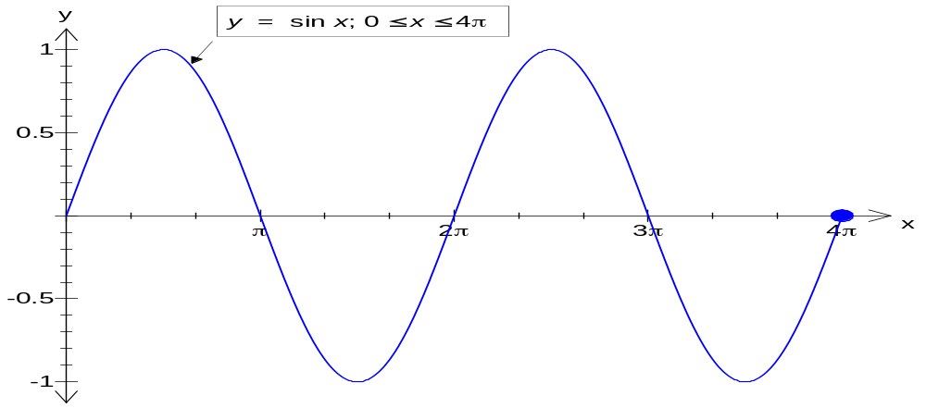

Domain chosen: 0 ≤ x ≤ 4л Range: -1, 1
Period: 2л Amplitude: 1
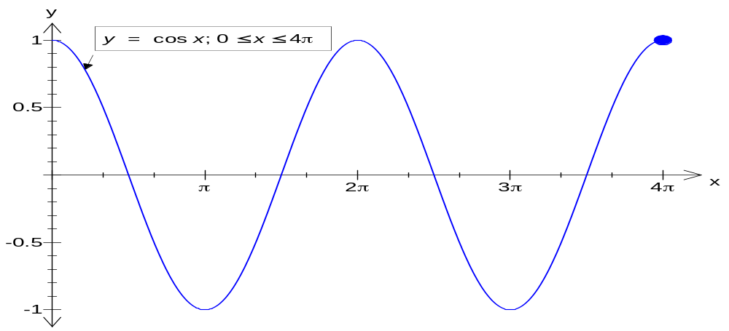

Domain chosen: 0 ≤ x ≤ 4л Range: -1, 1
Period: 2л Amplitude: 1

Investigating Trigonometric Functions

For all of the graphs in this investigation use the domain 0 ≤ x ≤ 2л if using your graphics calculator.

Part A:

1. On the axes below, plot: (a) y = sin x
(b) y = 2sin x [i.e. 2*sin x]
(c) y = 3sin x
(d) y = ½sin x
- y = -sin x

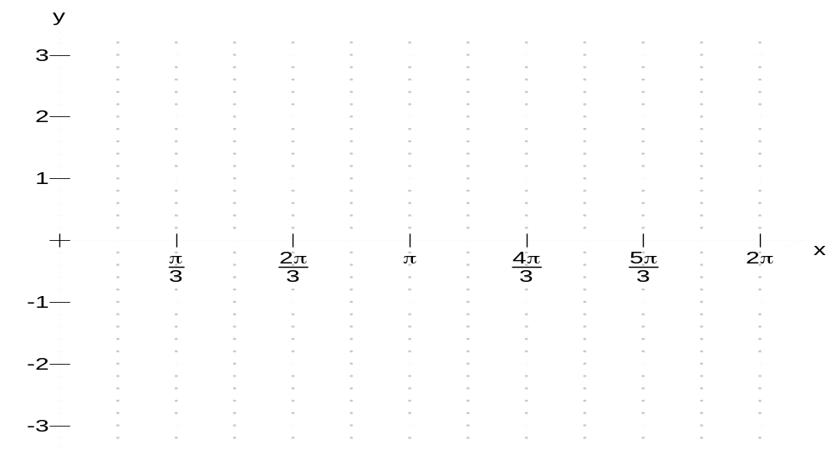

2. Fill in the following table related to the graphs above.

Graph | Period | Amplitude | Range
sin x
2sin x
3sin x
½sin x
-sinx
a sin x

3. What does the ‘a’ do to the graph?

a > 1
0 < a < 1
a < 0

4. On the axes below, plot: (a) y = cos x
(b) y = 2cos x
(c) y = 3cos x
(d) y = ½cos x
- y = -cos x

5. Fill in the following table related to the graphs above.

Graph | Period | Amplitude | Range
a cos x

6. On the axes below, plot: (a) y = tan x
(b) y = 2tan x
(c) y = 3tan x
(d) y = ½tan x
- y = -tan x

Remember to draw in the asymptotes.

7. Fill in the following table related to the graphs above.

Graph | Period | Amplitude | Range
a tan x |  | Not applicable

Part B:

On your calculator set the range as -2 ≤ y ≤ 2.
Use colours, label each graph and mark any x-intercepts carefully.

1. On the following set of axes plot: (a) y = sin x
- y = sin 2x [i.e. sin (2*x)]
- y = 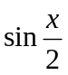

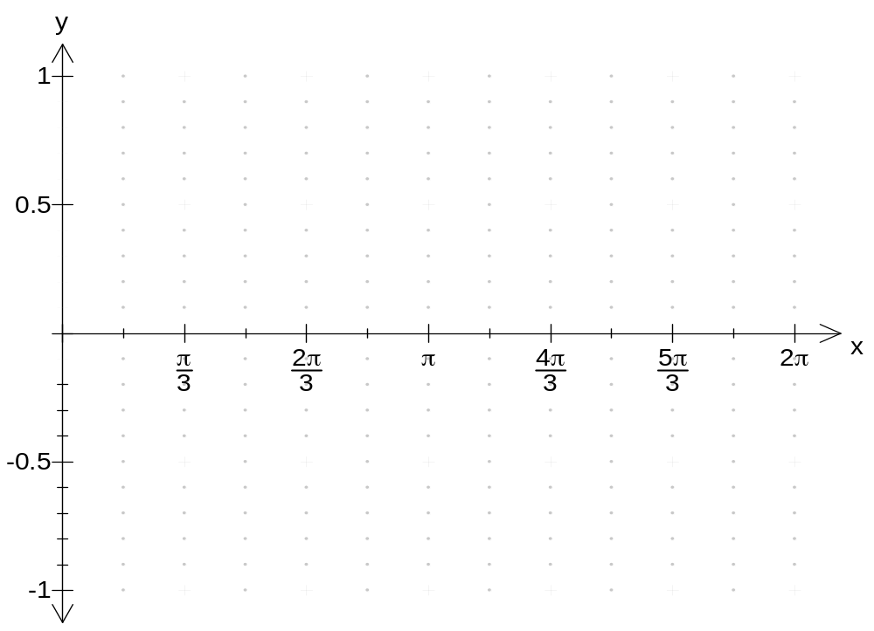

2. On the following set of axes plot: (a) y = sin 3x
(b) y = 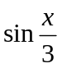

3. On the following set of axes plot: (a) y = sin 4x
(b) y = 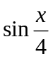

4. Fill in the following table that relates to the graphs above.

Graph | Period | Amplitude | Range
sin x
sin 2x
sin x/2
sin 3x
sinx/3
sin 4x
sin x/4
sin bx

5. What does the ‘b’ do to the graph?

b > 1
0 < b < 1

6. On the following set of axes plot: (a) y = cos x
- y = cos 2x
- y = 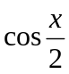

7. On the following set of axes plot: (a) y = cos 3x
(b) y = 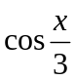

8. On the following set of axes plot: (a) y = cos 4x
(b) y = 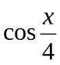

9. Fill in the following table that relates to the graphs above.

Graph | Period | Amplitude | Range
cos bx

PART C:

On your calculator, set the range as -4 ≤ y ≤ 4.
Mark your asymptotes and x-intercepts on each of the following.

- On the following set of axes plot y = tan x.

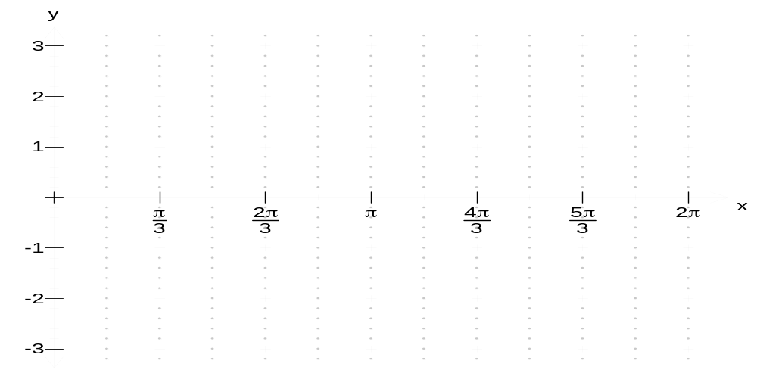

- On the following set of axes plot y = tan 2x.

- On the following set of axes plot y = tan 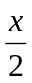.

- On the following set of axes plot y = tan 3x.

5. On the following set of axes plot y = tan 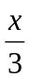.

6. On the following set of axes plot y = tan 4x.

7. Fill in the following table relating to the graphs above.

Graph | y = tan x | y = tan 2x | y = tan | y = tan 3x | y = tan | y = tan 4x
Period

- Fill in the following table relating to your findings from parts 1 → 6.

Graph | Period | Amplitude | Range
tan bx |  | Not applicable

PART D:

On your calculator, set your range as -2 ≤ y ≤ 2.

1. On the following set of axes plot: (a) y = sin x
(b) y = sin (x + )
(c) y = sin (x + )

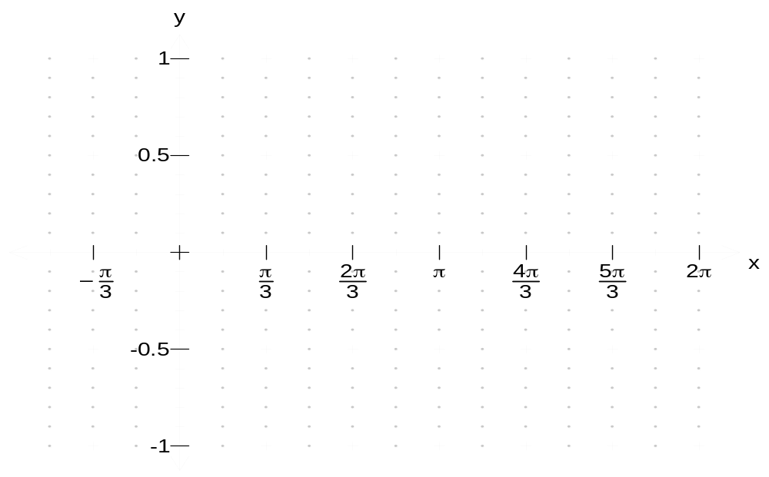

2. On the following set of axes plot: (b) y = sin (x - )
(c) y = sin (x - 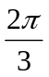)

3. On the following set of axes plot: (a) y = cos x
(b) y = cos (x + )
(c) y = cos (x + )

4. On the following set of axes plot: (b) y = cos (x - )
(c) y = cos (x - )

5. On the following set of axes plot: (a) y = tan x
(b) y = tan (x + )
(c) y = tan (x + )

6. On the following set of axes plot: (b) y = tan (x - )
(c) y = tan (x - )

7. Fill in the following table based on the information from the graphs above of y = sin (x + c)

Value of c | What the ‘c’ does to the graph
C > 0
C < 0

PART E:

On your calculator, set your range as -2 ≤ y ≤ 2.

- On the following set of axes plot y = sin 2x.

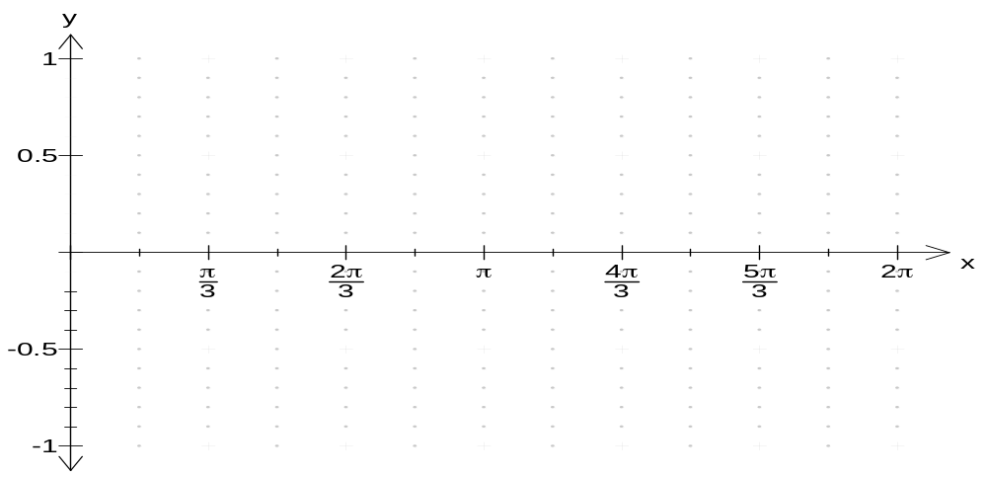

- On the following set of axes plot y = sin 2(x + ).
- On the following set of axes plot y = sin (2x + ).

- Fill in the following table based on parts 1 → 3.

Graph | Period | Horizontal shift
sin 2x
sin 2(x + )
sin (2x + )
sin b(x + c)
sin (bx + c)

PART F:

Use all of the information you have learned to draw the graphs of each of the following:

- y = a sin b(x +c).

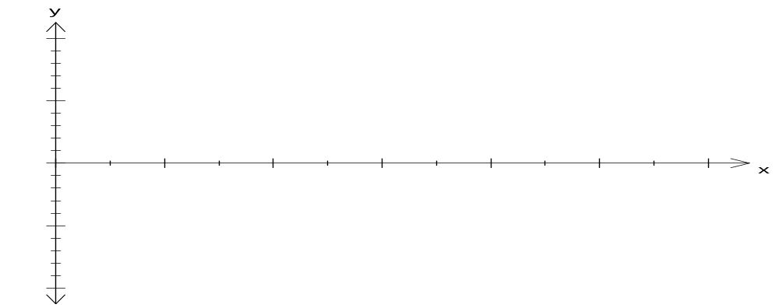
- y = a cos b(x +c).

- y = a tan b(x +c).

- Fill in the following table relating to parts 1 → 3.

Graph | Period | Amplitude | Range | Shift
y = a sin b(x +c)
y = a cos b(x +c)
y = a tan b(x +c)

